Forecast Apple Daily Stock Return using GARCH Modeling

Data source <http://finance.yahoo.com/quote/AAPL/history?p=AAPL>

(period: Apr 13, 2015 to Apr 8, 2020)

AAPL <- read.csv("C:/Users/Azamat/Downloads/AAPL.csv")

> View(AAPL)

> logret = diff(log(AAPL$Adj.Close), lag=1)

> aapl = AAPL [-c(1),]

> apple = cbind(aapl,logret)

> hist(logret)

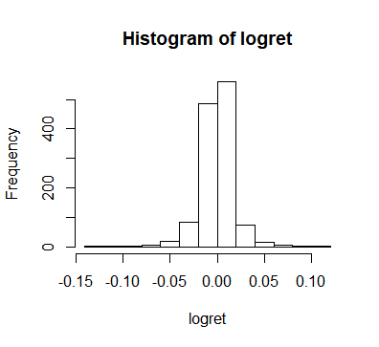

Logarithm of daily returns are normally distributed

Let’s look at the time plot for log daily return, log daily return squared

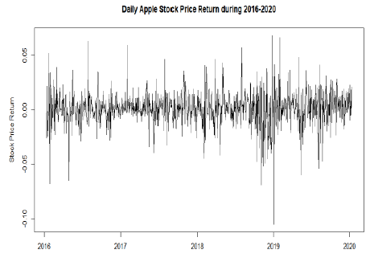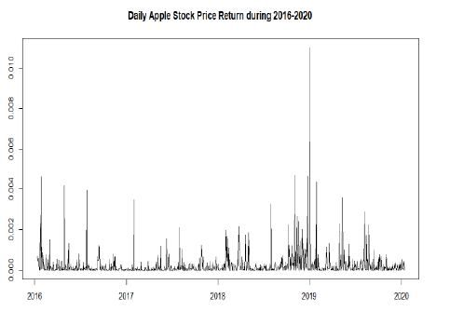

From the first graph we can see a clustering with high periodically high fluctuations, therefore, carries volatility in nature. Squared time series supports the first one. To understand the stationarity of the time series, ACF and PACF for log daily returns, squared log daily returns, and absolute difference of daily returns were performed:

* Log daily returns

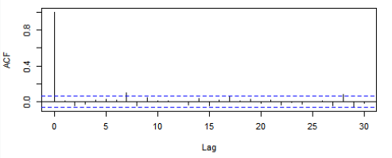

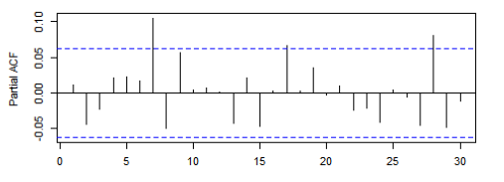

* Squared log daily retuns



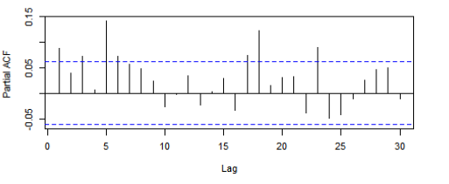

* Absolute difference of daily returns:

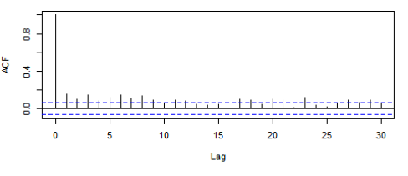

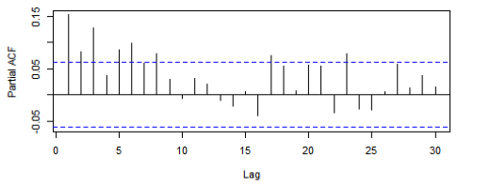

As we can see from the last 4 graphs, squared log daily returns and absolute daily returns have similar behaviour, i.e carries correlation.

The following model fitting was observed:

**Model 1**: AR(0)-GARCH(1,1) with normally distributed errors

**Model 2**: ARMA(0,0)-GARCH(1,1) model with t-distribution

**Model 3**: ARMA(0,0)-GARCH(1,1) model with skewed t-distribution

**Model 4**: Fit ARMA(0,0)-eGARCH(1,1) model with t-distribution

**Model 5**: Fit ARMA(0,0)-fGARCH(1,1) model with t-distribution

**Model 6**: Igarch model

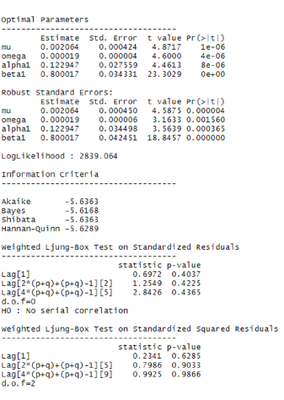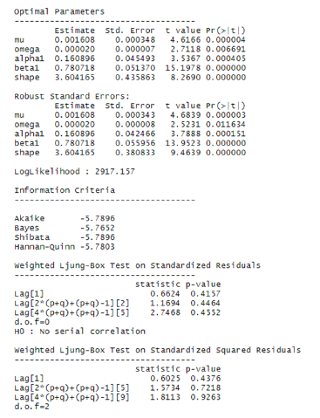

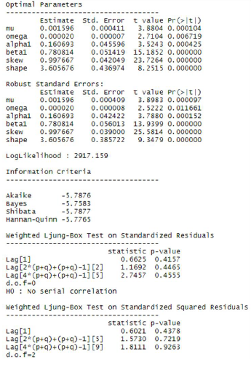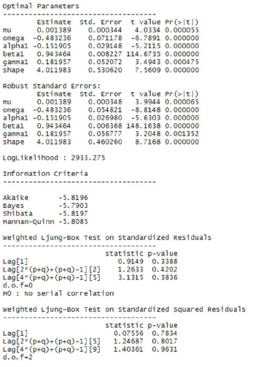

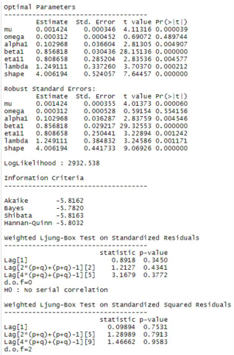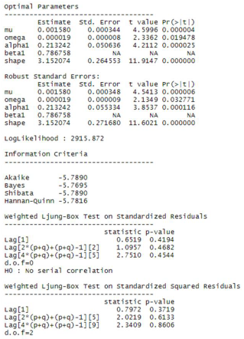

All of the Models from 1 to 6: have p-values for Ljung Box Test of residuals >0.05, so we conclude that there is no evidence of correlation

All models, except Model 5, have p-values for parameters <0.05, so we assume them as good models to proceed.

If we look to the Bayesian Information Criterion, the following values are at place:

**BIC (model 1) = -5.62**

**BIC (model 2) = -5.7652**

**BIC (model 3) = -5.76**

**BIC (model 4) = -5.79**

**BIC (model 5) = -5.7820 (but the p-value for parameters has no level of statistical significance)**

**BIC (model 6) = -5.7695**

Model 6 has lowest BIC value; therefore, we assume it to be the best model to proceed.

Based on the analysis above we proceed with IGARCH model for the t+1 period prediction

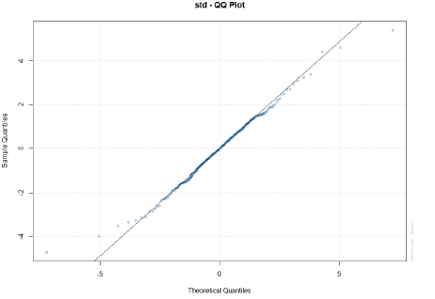

QQ-plot for standartized residuals shows almost normal distribution, with small spike at the tails.

To forecast t+1 period return, we use the following coding:

> o-roll forecast [T0=2020-04-09]:

Series Sigma

T+1 0.00158 0.01514

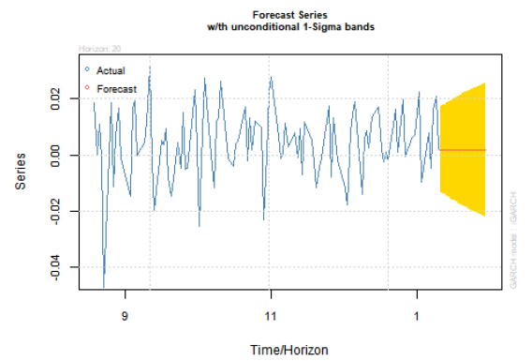

One sigma level represents estimated conditional volatility at t+1 period.

Series shows conditional mean evolution. The predicted mean is observed to be constant because model mean is constant.